**ListView練習**

1. 請參考投影片內容，建立以下的Android應用程式

並請將1.**建立過程**; 2.程式**執行結果**截圖; 2.程式**原始檔 copy&paste**置入作業中

請參考單元31的ListView程式

* 1. 建立具有**小圖示**的ListView 且具有ItemListener

* 1. ListView內容請自訂數個

MainActvity.java

**package** com.app.myapp;  
  
**import** android.content.res.TypedArray;  
**import** android.support.v7.app.AppCompatActivity;  
**import** android.os.Bundle;  
**import** android.view.View;  
**import** android.widget.AdapterView;  
**import** android.widget.ArrayAdapter;  
**import** android.widget.ListView;  
**import** android.widget.SimpleAdapter;  
**import** android.widget.TextView;  
  
**import** java.util.ArrayList;  
**import** java.util.HashMap;  
**import** java.util.List;  
**import** java.util.Map;  
  
**public class** MainActivity **extends** AppCompatActivity {  
  
 **private static final** String ***ITEM_TITLE*** = **"Item title"**;  
 **private static final** String ***ITEM_ICON*** = **"Item icon"**;  
  
 **private** TextView **mTxtR**;  
 **private** ListView **mListViewRegion**;  
  
 @Override  
 **protected void** onCreate(Bundle savedInstanceState) {  
 **super**.onCreate(savedInstanceState);  
 setContentView(R.layout.***activity_main***);  
  
 **mTxtR** = findViewById(R.id.***txtR***);  
 **mListViewRegion** = findViewById(R.id.***listViewRegion***);  
  
 String[] regionList = getResources().getStringArray(R.array.***fruit_list***);  
 TypedArray regionIconList =  
 getResources().obtainTypedArray(R.array.***region_icon_list***);  
 List<Map<String, Object>> itemList = **new** ArrayList<Map<String, Object>>();  
  
 **for** (**int** i = 0; i < regionList.**length**; i++) {  
 Map<String, Object> item = **new** HashMap<String, Object>();  
 item.put(***ITEM_TITLE***, regionList[i]);  
 item.put(***ITEM_ICON***, regionIconList.getResourceId(i, 0));  
 itemList.add(item);  
 }  
  
 SimpleAdapter simAdapListViewRegion = **new** SimpleAdapter(  
 MainActivity.**this**, itemList,  
 R.layout.***list_view_item***,  
 **new** String[] {***ITEM_TITLE***, ***ITEM_ICON***},  
 **new int**[] {R.id.***txtView***, R.id.***imgView***});  
 **mListViewRegion**.setAdapter(simAdapListViewRegion);  
  
 **mListViewRegion**.setOnItemClickListener(**listViewRegionOnItemClick**);  
 }  
  
 **private** AdapterView.OnItemClickListener **listViewRegionOnItemClick** = **new** AdapterView.OnItemClickListener() {  
 @Override  
 **public void** onItemClick(AdapterView<?> adapterView, View view, **int** i, **long** l) {  
 String s = getString(R.string.***region_selected***);  
 TextView txtView = view.findViewById(R.id.***txtView***);  
 **mTxtR**.setText(s + txtView.getText());  
 }  
 };  
}

strings.xml

<**resources**>  
 <**string name="app_name"**>ListView選單</**string**>  
  
 <**string-array name="fruit_list"**>  
 <**item**>草莓</**item**>  
 <**item**>蘋果</**item**>  
 <**item**>葡萄</**item**>  
 <**item**>番茄</**item**>  
 <**item**>檸檬</**item**>  
 </**string-array**>  
 <**string name="region_selected"**>您選擇的水果：</**string**>  
  
 <**string-array name="region_icon_list"**>  
 <**item** >@drawable/strawberry</**item**>  
 <**item** >@drawable/apple </**item**>  
 <**item** >@drawable/grape </**item**>  
 <**item** >@drawable/tomato </**item**>  
 <**item** >@drawable/lemon </**item**>  
 </**string-array**>  
  
</**resources**>

Activity_main.xml

*<?***xml version="1.0" encoding="utf-8"***?>*<**LinearLayout xmlns:android="http://schemas.android.com/apk/res/android"  
 android:layout_width="match_parent"  
 android:layout_height="match_parent"  
 android:orientation="vertical"**>  
  
 <**TextView  
 android:id="@+id/txtR"  
 android:text="TextView"  
 android:textSize="18sp"  
 android:layout_width="match_parent"  
 android:layout_height="wrap_content"** />  
  
 <**ListView  
 android:id="@+id/listViewRegion"  
 android:layout_width="match_parent"  
 android:layout_height="wrap_content"** />  
</**LinearLayout**>

List_view_item.xml

*<?***xml version="1.0" encoding="utf-8"***?>*<**LinearLayout xmlns:android="http://schemas.android.com/apk/res/android"  
 android:orientation="horizontal"  
 android:layout_width="match_parent"  
 android:layout_height="match_parent"  
 android:padding="10dp"** >  
  
 <**ImageView  
 android:id="@+id/imgView"  
 android:layout_width="wrap_content"  
 android:layout_height="match_parent"** />  
  
 <**TextView  
 android:id="@+id/txtView"  
 android:layout_width="match_parent"  
 android:layout_height="match_parent"  
 android:textSize="20sp"  
 android:paddingLeft="10dp"** />  
  
</**LinearLayout**>

1. 請參考**單元34**的SeekBar與RatingBar程式
   1. 畫面中有SeekBar與RatingBar
   2. 使用者調整SeekBarg時, RatingBar的星星也跟著連動調整 並顯示數值
   3. 反之亦然,使用者調整RatingBar的星星,SeekBar也會跟著調整

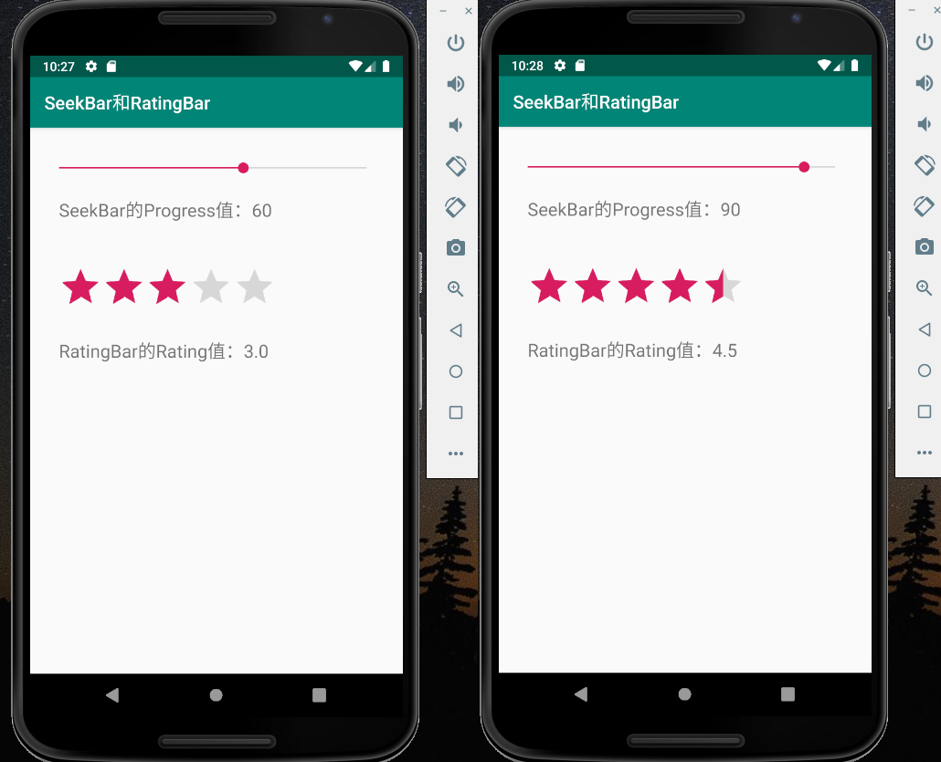

MainActivity.java

**package** com.app.myapp;  
  
**import** android.support.v7.app.AppCompatActivity;  
**import** android.os.Bundle;  
**import** android.widget.RatingBar;  
**import** android.widget.SeekBar;  
**import** android.widget.TextView;  
  
**public class** MainActivity **extends** AppCompatActivity {  
  
 **private** RatingBar **mRatingBar**;  
 **private** SeekBar **mSeekBar**;  
 **private** TextView **mTxtSeekBarProgress**,  
 **mTxtRatingBarValue**;  
  
 @Override  
 **protected void** onCreate(Bundle savedInstanceState) {  
 **super**.onCreate(savedInstanceState);  
 setContentView(R.layout.***activity_main***);  
  
 **mRatingBar** = findViewById(R.id.***ratingBar***);  
 **mSeekBar** = findViewById(R.id.***seekBar***);  
 **mTxtSeekBarProgress** = findViewById(R.id.***txtSeekBarProgress***);  
 **mTxtRatingBarValue** = findViewById(R.id.***txtRatingBarValue***);  
  
 **mSeekBar**.setOnSeekBarChangeListener(**seekBarOnChange**);  
 **mRatingBar**.setOnRatingBarChangeListener(**ratingBarOnChange**);  
 }  
  
 **private** SeekBar.OnSeekBarChangeListener **seekBarOnChange** =  
 **new** SeekBar.OnSeekBarChangeListener() {  
 @Override  
 **public void** onProgressChanged(SeekBar seekBar, **int** i, **boolean** b) {  
 String s = getString(R.string.***seek_bar_progress***);  
 **mTxtSeekBarProgress**.setText(s + String.*valueOf*(i));  
 **mRatingBar**.setRating((**float**)i/20);  
 }  
  
 @Override  
 **public void** onStartTrackingTouch(SeekBar seekBar) {  
 }  
  
 @Override  
 **public void** onStopTrackingTouch(SeekBar seekBar) {  
 }  
 };  
  
 **private** RatingBar.OnRatingBarChangeListener **ratingBarOnChange** =  
 **new** RatingBar.OnRatingBarChangeListener() {  
 @Override  
 **public void** onRatingChanged(RatingBar ratingBar, **float** v, **boolean** b) {  
 String s = getString(R.string.***rating_bar_value***);  
 **mTxtRatingBarValue**.setText(s + String.*valueOf*(v));  
 **mSeekBar**.setProgress((**int**)(v*20));  
 }  
 };  
}

activity_main.xml

*<?***xml version="1.0" encoding="utf-8"***?>*<**android.support.constraint.ConstraintLayout xmlns:android="http://schemas.android.com/apk/res/android"  
 xmlns:app="http://schemas.android.com/apk/res-auto"  
 xmlns:tools="http://schemas.android.com/tools"  
 android:layout_width="match_parent"  
 android:layout_height="match_parent"  
 tools:context=".MainActivity"**>  
  
 <**SeekBar  
 android:id="@+id/seekBar"  
 android:layout_width="0dp"  
 android:layout_height="wrap_content"  
 android:layout_marginStart="16dp"  
 android:layout_marginLeft="16dp"  
 android:layout_marginTop="8dp"  
 android:layout_marginEnd="24dp"  
 android:layout_marginRight="24dp"  
 android:layout_marginBottom="8dp"  
 android:max="100"  
 android:progress="80"  
 app:layout_constraintBottom_toBottomOf="parent"  
 app:layout_constraintEnd_toEndOf="parent"  
 app:layout_constraintHorizontal_bias="0.493"  
 app:layout_constraintStart_toStartOf="parent"  
 app:layout_constraintTop_toTopOf="parent"  
 app:layout_constraintVertical_bias="0.048"** />  
  
 <**RatingBar  
 android:id="@+id/ratingBar"  
 style="?android:attr/ratingBarStyle"  
 android:layout_width="wrap_content"  
 android:layout_height="wrap_content"  
 android:layout_marginTop="48dp"  
 android:numStars="5"  
 android:rating="3.5"  
 app:layout_constraintEnd_toEndOf="@+id/txtSeekBarProgress"  
 app:layout_constraintHorizontal_bias="0.0"  
 app:layout_constraintStart_toStartOf="@+id/txtSeekBarProgress"  
 app:layout_constraintTop_toBottomOf="@+id/txtSeekBarProgress"** />  
  
 <**TextView  
 android:id="@+id/txtSeekBarProgress"  
 android:layout_width="0dp"  
 android:layout_height="wrap_content"  
 android:layout_marginStart="16dp"  
 android:layout_marginLeft="16dp"  
 android:layout_marginTop="24dp"  
 android:text="@string/seek_bar_progress"  
 android:textSize="20sp"  
 app:layout_constraintEnd_toEndOf="@+id/seekBar"  
 app:layout_constraintHorizontal_bias="0.0"  
 app:layout_constraintStart_toStartOf="@+id/seekBar"  
 app:layout_constraintTop_toBottomOf="@+id/seekBar"** />  
  
 <**TextView  
 android:id="@+id/txtRatingBarValue"  
 android:layout_width="0dp"  
 android:layout_height="wrap_content"  
 android:layout_marginTop="24dp"  
 android:text="@string/seek_bar_progress"  
 android:textSize="20sp"  
 app:layout_constraintEnd_toEndOf="@+id/ratingBar"  
 app:layout_constraintHorizontal_bias="0.0"  
 app:layout_constraintStart_toStartOf="@+id/ratingBar"  
 app:layout_constraintTop_toBottomOf="@+id/ratingBar"** />  
  
</**android.support.constraint.ConstraintLayout**>